**ASSIGNMENT 1 FRONT SHEET**

|  |  |  |  |
| --- | --- | --- | --- |
| **Qualification** | **BTEC Level 5 HND Diploma in Computing** | | |
| **Unit number and title** | Unit 13:Computing Research Project | | |
| **Submission date** |  | **Date Received 1st submission** |  |
| **Re-submission Date** |  | **Date Received 2nd submission** |  |
| **Student Name** | Nguyễn Trọng Duy | **Student ID** | GCD17313 |
| **Class** | GCD0901 | **Assessor name** | Phyo Min Tun |
| **Student declaration**  I certify that the assignment submission is entirely my own work and I fully understand the consequences of plagiarism. I understand that making a false declaration is a form of malpractice. | | | |
|  |  | **Student’s signature** | Duy |

**Grading grid**

|  |  |  |  |  |  |  |  |  |  |
| --- | --- | --- | --- | --- | --- | --- | --- | --- | --- |
| P1 | P2 | P3 | P4 | P5 | M1 | M2 | M3 | D1 | D2 |
|  |  |  |  |  |  |  |  |  |  |

|  |  |  |  |  |  |  |
| --- | --- | --- | --- | --- | --- | --- |
| **❒ Summative Feedback: ❒ Resubmission Feedback:** | | | | | | |
| **Grade:** | | **Assessor Signature:** | | | **Date:** | |
| **Internal Verifier’s Comments:** | | | | | | |
| **Signature & Date:** | | | | | | |
| **Learning Outcomes and Assessment Criteria** | | | | | | |
| **Pass** | | **Merit** | **Distinction** | |
| **LO1** Examine appropriate research methodologies and approaches as part of the research process | | | **LO1 & 2**  **D1** Critically evaluate research methodologies and processes in application to a computing research project to justify chosen research methods and analysis. | |
| **P1** Produce a research proposal that clearly defines a research question or **hypothesis** supported by a literature review.  **P2** Examine appropriate **research methods** and approaches to **primary and secondary research.** | | **M1** Evaluate different research approaches and methodology and make justifications for the choice of methods selected based on philosophical/theoretical frameworks. |
| **LO2** Conduct and analyse research relevant for a computing research project | | |
| **P3** Conduct primary and secondary research using appropriate methods for a computing research project that consider costs, **access and ethical issues.**  **P4** Apply appropriate analytical tools, analyse research findings and data. | | **M2** Discuss merits, limitations and pitfalls of approaches to data collection and analysis. |
| **LO3** Communicate the outcomes of a research project to identified stakeholders | | | **D2** Communicate critical analysis of the outcomes and make valid, justified recommendations. | |
| **P5** Communicate research outcomes in an appropriate manner for the intended audience. | | **M3** Coherently and logically communicate outcomes to the intended audience demonstrating how outcomes meet set research objectives. |

# Table of Contents

Contents

Table of Contents 3

-What is Monitoring and productivity tools, key uses and security concerns when working remotely? 5

-Is Working remotely for Business important to us? 5

ACKNOWLEDGEMENTS 5

Introduction: 6

The scientific research project for this issue: 7

Planning Project 7

PURPOSE OF RESEARCH 7

Literature Review 7

RESEARCH METHODOLOGIES 7

-Prinary Research 7

-Secondary Research 8

-Qualitative research & Quantitative research 11

-Scientific method 13

-Steps of the Scientific Method 14

-Research process 17

SECONDARY RESEARCH 17

Definition of remote working 17

9 difficulties types of working from home and how to overcome them 18

Best APP for working at home 20

Conclusion and propose an initial hypothesis 21

Hypotheses for research: 22

PRIMARY RESEARCH 22

Research Subject 22

-Research Object 22

-Research Plan 23

Sample Size 25

Sampling Methods 25

Research Plan 26

Phase 3: Survey adult who have over 18 years old 26

Phase 4: Analyze the collected data after the survey 29

-Research Ethics Approval Form 32

CONCLUSION 40

Bibliography 40

GREENWICH UNIVERSITY

Computing research project

The effect of Working remotely for Business and technology solutions for Digital transformation strategies to Monitoring ,productivity tools, key of uses and security concerns when working remotely

**Student: Nguyen Trong Duy**

**ID: GCD17313**

# -What is Monitoring and productivity tools, key uses and security concerns when working remotely?

# -Is Working remotely for Business important to us?



# ACKNOWLEDGEMENTS

Scientific research essay on: Remote working towards digital transformation strategy, monitoring tools, productivity, digital transformation strategy and Monitoring and productivity tools. My class teacher is Mr. Phyo Min Tun, who has guided and helped me a lot in this scientific research process. In addition, I would like to thank my teacher who have helped and helped me complete this scientific research and thank the school for helping me to participate in this course so that I can research and study. I learned a lot of things that I didn't know. but. In the past time, I have tried a lot in scientific research to complete the report in the best way and send it to the lecturers and I look forward to receiving valuable comments from the lecturers. members and their own contributions. 

## Introduction:

**-General introduction**

The previous epidemic years are disastrous for workers and specialized sectors. With the threat of isolation and social alienation in many nations, which has led many occupations and activities to be postponed forever, getting off the road is sort of feasible. Adapting to and managing the potential because the epidemic might not be over, several nations have moved to remote work and regard this as a positive step like a spontaneous experiment

Epidemics emerge when technology progresses. The vast majority of organizations have shifted part or all of their activities online like Remote Working, and nearly all workers now work from home. Employees are hesitant to work remotely for a variety of reasons, including productivity concerns, security concerns, and technological challenges. The most common issues that remote employees confront include frequent network disconnections, sluggish file downloads, poor video meeting quality, and delayed reaction times when launching apps.

When the quantity of persons immunized against covid 19 began to extend in many nations, many countries began to relax and establish a replacement normal, making travel and activities normal and dealing people ready to work. With the choice to figure face-to-face or remotely, most people choose to work remotely since it's more efficient and productive. And for this study, I'll write about "monitoring and productivity tools when working remotely."

Below, I will do a research paper on the impact of Remote Working being adopted by some businesses in the pre-pandemic era.



## The scientific research project for this issue:

The biggest issues remote workers face is being frequently disconnected from corporate networks, slow file downloads, poor quality of video meetings and long response times when loading apps.

## Planning Project

-Research objectives : technology solutions for Digital transformation strategies to Monitoring ,productivity tools, key of uses and security concerns when working remotely

## PURPOSE OF RESEARCH

The purpose of this article is on the topic of Remote Working. For this purpose, I will research and discuss ways Digital Transformation Strategies for Work and Work productivity and monitoring tools for businesses? Also, How can we improve slow file download quality, poor video meeting quality and long response time when loading apps?

### Aim and Objective Scope:

-Consider and compare remote working apps to other accessible goods that have changed and have an impact on how we work and live, as well as how we may improve them.

-Compare software and programs for appropriateness for the job.

-How apps affect our work habits and how we adjust to them.

### Research Question:

-What are the advantages of using online meeting apps for remote work, and how do they compare to in-person meetings?

-What are the many features and benefits of apps, and how do they impact your productivity?

### Methodologies and approach to research:

I utilize the survey technique because I want to collect more and more large amounts of data from the community in a cost-effective manner.

This survey was conducted using a questionnaire and a Research Plan study design.

# Literature Review

## RESEARCH METHODOLOGIES

Discuss research methodologies

-**Definition**

-About Primary & Secondary Research

### -Prinary Research

Prinary Research is defined a method tope reasearch that you collect by my-self for collect data directly (Focus Group), included online surveys, observations interviews (Telephone or face-to face) and etthnographic Research

Primary research is solely carried out to address a certain problem which requires in-depth analysis. A good research need know how to use both Primary and Secondary Research intergrate them for focus in every writing project. It’s an excellent skill to learn as it can be useful in a variety of settings including business, personal and academic. Do Research is a usefull skill way to acquire as it can greatly supplement for your research in secondary sources such as journals, magazines or books.

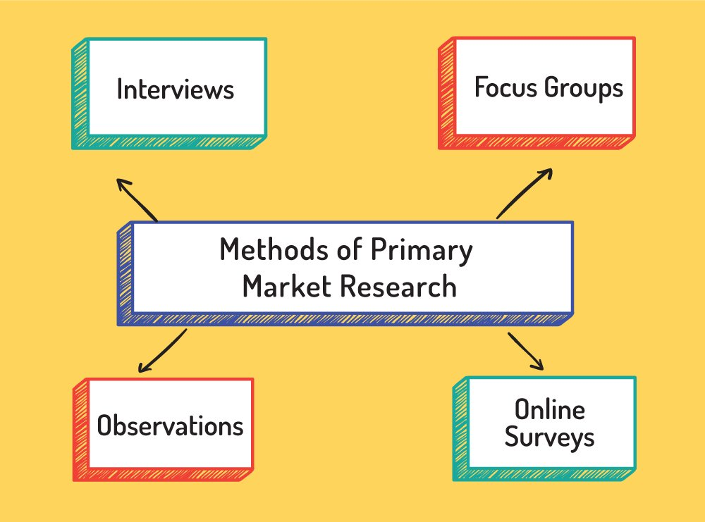

### -Secondary Research

Secondary Research is defined a method tope research that you involves using already existing data available on the internet includes from research material published in research reports, similar documents, Educational Institutions, in Public libraries, or Commercial information sources   
Existing data is “summarized and collated" to increase the overall effectiveness of research. These documents can be made available by public libraries, websites, data obtained from already filled in surveys etc. Some government and non-government agencies also store data, that can be used for research purposes and can be retrieved from them.

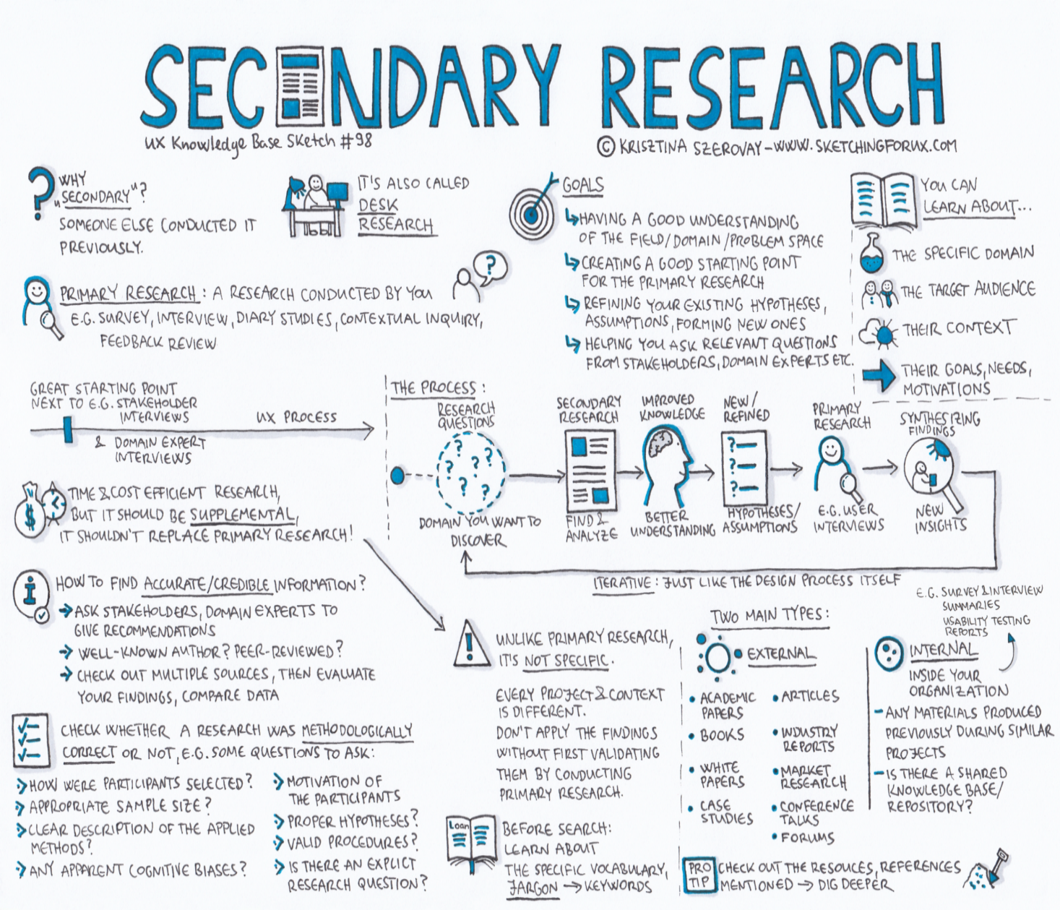

#### The Comparisons Chart

|  |  |  |
| --- | --- | --- |
| **Basic for comparisons** | **Primary research** | **Secondary research** |
| Based on | Unprocessed datas | Analyze and explain the information |
| Carried on | Researcher himself or herself | Someone else |
| Data | Specifically tailored to the demands of the researcher | It may or may not be tailored to the demands of the researcher. |
| Process | Extremely Involved | Quick and simple |
| Cost | High | Low |
| Time | Long | Short |

#### Cons, Pros

##### Primary Research

|  |
| --- |
| **Pros of Primary Research**  One of the most important advantages is, Primary research is a time-tested method allows researchers deeply involved in research to collect data in primary research conducted first hand for obtain and collect data to go in depth of a matter and study all foreseeable options and gives a means to control how data is collected and used. It’s up to the discretion of businesses or organizations who are collecting data how to best make use of data to get meaningful research insights.  Data collected is first hand and is accurate and can be controlled and fits the needs of a researcher, it is customized and based on the absolute needs of organizations or businesses. In other words, there is no dilution of data. Also, this research method can be customized to suit personal requirements and needs of organizations or businesses. Therefore, one can rely on the results that are obtained from conducting this type of research by focuses mainly on problem in hand, which means entire attention is directed to find probable solution to a pinpointed subject matter. |
| **Cons of Primary Research**  Primary research is based on raw data, an expensive process and consumes a lot of time to collect and analyze data.  One of the major disadvantages of primary research is, it can be quite expensive to conduct for required to spend a huge sum of money depending on the setup or primary research method used. Not all businesses or organizations may be able to spend a considerable amount of money. Sometimes just using one primary research method may not be enough.  This type of research can be time-consuming.  In such cases, use of more than one method is required and this might increase both times required to conduct research, interviews, sending and receiving online surveys can be quite an exhaustive process and need investing time and patience for the process to work. Moreover, evaluating results and applying the findings to improve product or service will need additional time and the cost associated with it. |

##### Secondary Research

|  |
| --- |
| **Pros of Secondary Research**  Based on data collected from previous reseaches and tried and tested data which is previously analyzed and filtered.  The data may or may not be according to the requirement of a researcher and that is collected through secondary research, gives organizations or businesses an idea about the effectiveness of primary research. Hence, organizations or businesses can form a hypothesis and evaluate cost of conducting primary research.  Secondary research is fast ,easy and a quick process as data is already available. This is a less expensive and less time-consuming process as data required is easily available and doesn’t cost much if extracted from authentic sources. A minimum expenditure is associated to obtain data. It aims at gaining a broader understanding of subject matter. Researcher should know where to explore to get most appropriate data.  Most information is secondary research is readily available. There are many sources from which relevant data can be collected and used, unlike primary research, where data needs to collect from scratch.  Secondary research is quicker to conduct because of availability of data. Secondary research can be completed within a few weeks depending on the objective of businesses or scale of data needed. |
| **Cons of Secondary Research**  Although data is readily available but not all secondary data resources offer the latest reports and statistics, credibility evaluation must be performed to understand the authenticity of the information available.  Even when the data is accurate, it may not be updated enough to accommodate recent timelines.  Secondary research derives its conclusion from collective primary research data.  The success of your research will depend, to a greater extent, on the quality of research already conducted by primary research. |

### -Qualitative research & Quantitative research

#### Qualitative research

Qualitative research is defined as a market research method that focuses on obtaining data through open-ended and conversational communication and methods allow focuses on to describe individual experiences and beliefs and for in-depth and further probing and questioning of respondents based on their responses, where the interviewer/researcher also tries to understand their motivation and feelings. Understanding how your audience takes decision can help derive conclusion in market research.

This method is not only about “what” people think but also “why” they think so by Process of observation, One-on-One Interview and keeping Record them when ask on Focus groups.

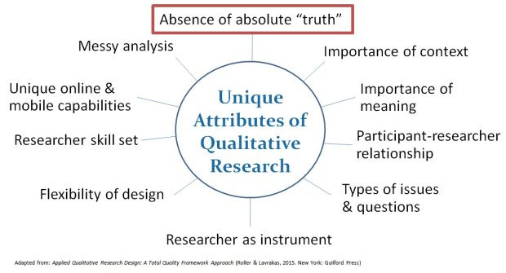

#### Quantitative research

Quantitative research is defined as a survey for collecting and analyzing data information on the basis of systematic data collected from the market by collecting quantitative data. and perform statistical, mathematical or computational techniques.

Quantitative research is mainly done in the social sciences using the statistical methods used above to collect quantitative data from research such as information collection from existing clients. At and potential using methods of sampling and sending online surveys, online surveys, questionnaires, etc., the results can be described in numerical form. After carefully understanding these numbers to predict the future of the product or service and make corresponding changes.

In this research method, researchers and statisticians develop mathematical frameworks and theories related to quantity by question. The goal is to draw conclusions through the use of statistical methods to process data using a structured method and conducted on larger samples that represent the entire population and data.

Consistent in the study of attitudes, opinions and behaviors of the people surveyed. The results of quantitative research samples are objective, meticulous, and many times, even research. The results obtained from this research method are reasonable, statistical and unbiased from a sample group to be generalized to a larger sample population.

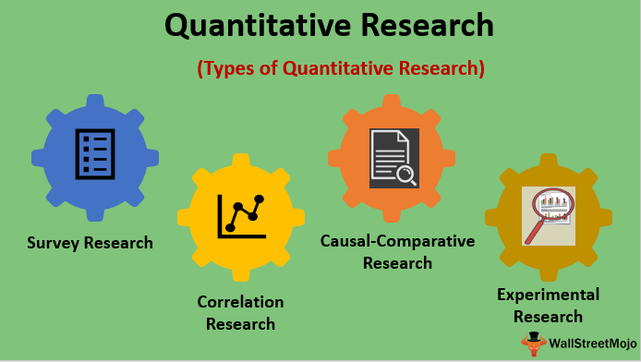

#### Pros,Cons

##### Qualitative research, Quantitative research

|  |
| --- |
| **Pros of Qualitative research**  The problem seen from the perspective of an insider: The fact that a qualitative researcher helps to allow for ambiguity / inconsistencies in the data is a reflection of social reality (Denscombe 2010). Due to the behavioral factors, the attitude of the research subjects, the use of unstructured research methods, the flexibility is very high, a descriptive, narrative style, this research can be beneficial. useful for the practitioner because she can turn to qualitative reports to test for the types of knowledge that may not be available, thus gaining new insights, playing an important role that will help us in proposing possible relationships, effects, causes, dynamic processes and better understanding the issues that quantitative research is easily overlooked.  Help discover useful information quickly.  The time to conduct a qualitative research project is usually shorter and costs less than quantitative research.  Due to the close involvement of the researcher, the researcher gets an insider's perspective on the field. This allows researchers to find issues that are often overlooked (such as sophistication and complexity) with more aggressive, scientific requirements. |
| **Cons of Qualitative research**  Being subjective, the generalization of research results must have a good understanding of the research field as well as deepening and analytical techniques in order to obtain the most accurate and valuable information. The qualitative research design could not have a large sample and the results of the qualitative research had a lot of subjectivity on the whole, which was limited in the reliability of the research results. .  Because of validity or complete reliability issues is a big criticism. Due to the subjective nature of the qualitative data and its origin in single contexts, it is often difficult to apply common standards of reliability and validity, with regard to the costs and time required to collecting and analyzing data for a fairly long qualitative study, the average difficulty of a qualitative survey usually lasts about 30 minutes, this can make respondents feel uncomfortable and bored. discouraged.  The transparency of qualitative research is lower than that of quantitative research, for example on some sensitive issues, the researcher will keep the respondent's identity confidential.  Due to the time required to collect, analyze and interpret long data. Analysis of qualitative data is difficult and expertise in an area is needed to try to interpret qualitative data, and care must be taken in doing so.  Due to the central role of the researcher in creating data, qualitative studies cannot be reproduced. In addition, the context, situations, events, conditions, and interactions cannot be scaled to any degree and cannot be generalized to a broader context than research with confidence. In search of symptoms such as mental illness and related costs, qualitative designs often do not sample from large datasets. |
| **Pros of Quantitative research**  Scientific objectivity: Quantitative data can be explained  and rapid analysis using analytical software to help process large amounts of data quickly and accurately with high reliability, minimizing technical errors that may arise due to child factors. People in the data processing of research results by sophisticated software eliminate most of the need for long-term data analysis, especially with large volumes of data involved (Antonius, 2003), high representativeness Therefore, quantitative research results are perfectly suitable for testing hypotheses that can also be tested because the use can be generalized to the whole sample, by statistical analysis and because statistics are based on Because of mathematical principles, quantitative method is considered a scientific and reasonable method. (Carr, 1994; Denscombe, 2010). So useful for checking and validating theories that have been formulated.  Copying: Quantitative data is based on measured values ​​and can be checked by others because singular data opens to the ambiguity of interpretation. |
| Cons of Quantitative research  Subjective factors of surveyors: Quantitative researchers do not clarify the human phenomenon (behavioral research), may miss valuable details of the survey if too focused on testing set the assumptions.  Differences in the way questions are understood: Occurs when the interviewees did not understand the questions posed by the researchers' intentions but understood differently and responded according to their interpretations. For quantitative research, the majority of interviewees are unable to intervene, explain or clarify questions to respondents.  Contextual errors may affect the content of the survey.  Research with poor knowledge of the application of statistical analysis can negatively affect subsequent analysis and interpretation (Black, 1999), using more sophisticated research methods than qualitative and therefore costly. More time to design quantitative research processes assumes that human behavior and attitudes do not change according to context. However, the object's answers may vary depending on different contexts.    Because of the need for a large sample to generalize the population, the cost of conducting a quantitative study does not take place in natural settings. In addition, they do not allow participants to explain their options or the meaning of possible questions for those participants, often very large, much larger than qualitative research.  Change in the amount of data: Large sample sizes are needed for more accurate analysis. Small quantitative studies may be less reliable because of the low amount of data (Denscombe, 2010). This also affects the ability to generalize research findings to a wider population.  Affirmative affirmation: Researchers may miss observing phenomena because they focus on theoretical testing or hypothesis testing rather than the theory of hypothesis creation. |

### -Scientific method

Since the 17th century, the methodology has been wont to gather information via experimentation. Scientific approaches have emerged because the gold standard for studying the nature. This assists scientists in arriving at the right conclusion and updating their past knowledge. Includes: Measurement, methodical observation, testing, and also the formulation of hypotheses or questions are all a part of it.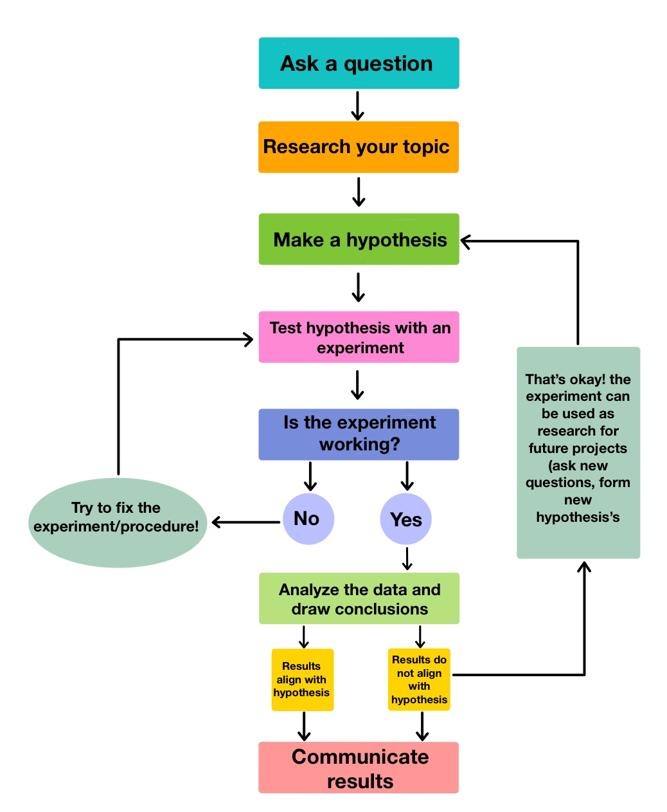

### -Steps of the Scientific Method

1. Ask a question:

When you pose an issue about what you see, you employ the scientific method like: How, What, When, Who, Which, Why, or Where?

Here are some resources to assist you with this step:

- Laboratory Notebook

- Your Question

2. Do background research:

Instead of beginning with a technique to repair a problem, learn the way to conduct research and use libraries and also the internet to help guarantee that the data you provide is more reliable. and avoid making the identical mistakes as within the past.

Use the research to assist you with this step:

-A basic research strategy

-Information search

-Folder

-Research papers

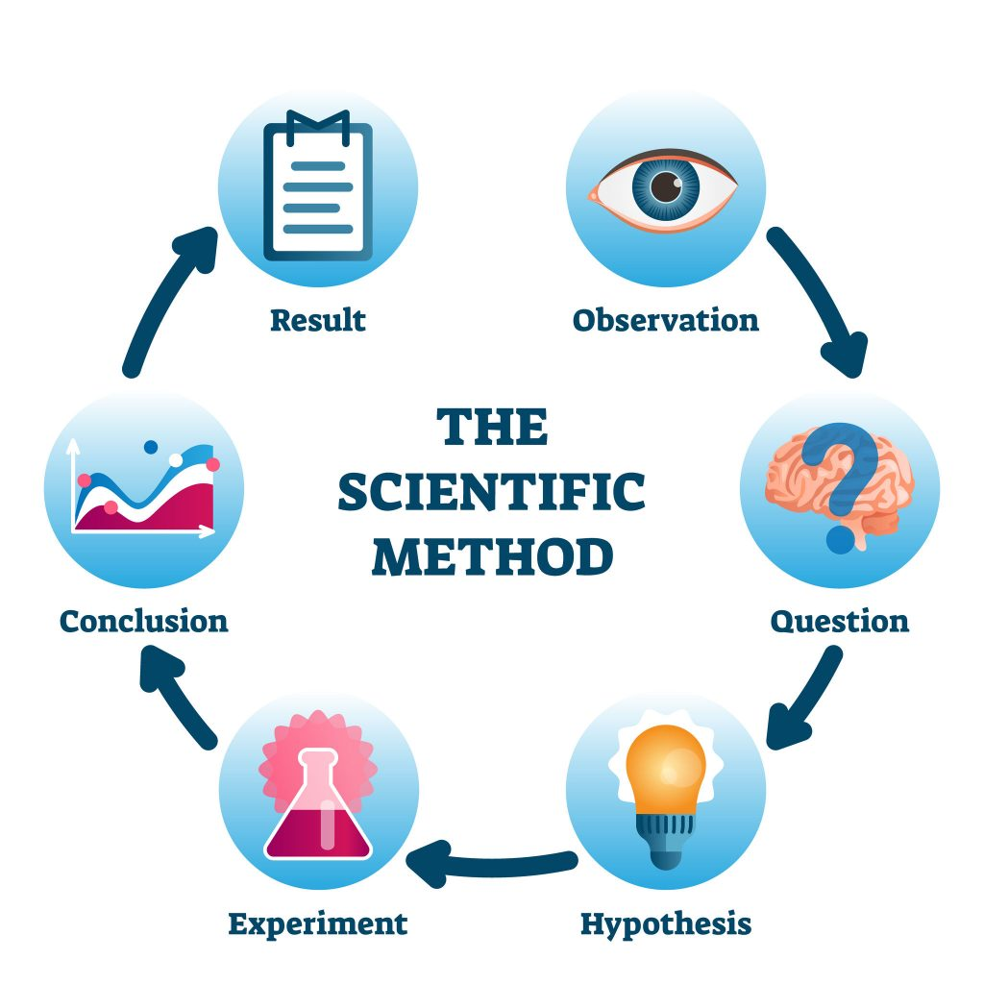

3. Create a Hypothesis

A hypothesis may be a well-informed assumption about how things operate. Here's a way to answer your inquiry with a testable explanation. A decent hypothesis allows you to anticipate what's going to happen:

"If ____ [I do this] _____, then ____ [this] is what's going to happen."

Use the subsequent resources:

-Variables

-Beginner Variables

-Hypothesis

4. Test Your Hypothesis by Doing an Experiment

Test the hypothesis by conducting an experiment to make sure that the prediction is true, but the experiment must be fair. Fair inspections are dole out by altering one element at a time while maintaining the identical condition. Furthermore, it's advised that trials be repeated numerous times to attain high precision.

Use the subsequent resources:

-Experimental methods

-List of materials

-Perform an experiment

5. Analyze Your Data and Draw a Conclusion

When your experiment is over, you gather your data and examine it to work out if it supports your hypothesis.

After performing the experiment, gather the info and examine it to work out if it supports the hypothesis. the bulk of scientists discover that their assumptions are wrong and unsubstantiated. In such circumstances, they're going to explain the outcomes of their tests and develop a brand new hypothesis or prediction supported what they learnt within the lab.

Use the subsequent resources:

-Graphs and Data Analysis

-Conclusions

6. Communicate Your Results

To finish a science fair project, you need to present your findings to others within the final report.

The majority of scientists do the identical thing: they publish their final report in a very scientific publication.

Use the subsequent resources:

-Abstract

-Advertising board

-Completed report

-Reviews of scientific literature

### -Research process

Step 1: Identify the Problem

The first stage within the procedure is to spot the matter or to ascertain a look topic. That research challenge might alternatively be anything that the agency determines is a difficulty or some knowledge that the agency requires.

Step 2: Review the Literature

After identifying the matter, the researcher must learn more about the topic under investigation. Researchers must evaluate research-related publications that give background about the subject area. Document review may help educate researchers about previous studies, yet as how researchers are frequently performed and concluded within the relevant field.

Step 3: Clarify the Problem

The researcher must explain the matter and reduce the realm of the investigation during this stage to make sure simple control. this can be done only after the paper has been evaluated. The knowledge received through reviewing a pursuit guide for the aim of clarifying and restricting research tasks.

Step 4: Clearly Define Terms and Concepts

The objective of the study description is often defined in terms of vocabulary and ideas. When applying for the study, this could be clearly stated. The meanings of the terminologies and ideas vary supported the study reader. to help prevent uncertainty regarding the meaning of terms and phrases, the researcher must precisely identify them for the study.

Step 5: Identify the Population

- The study's goal is to assist the researcher identify the research group. The groups that are often participating within the study are remarked because the population in research language. The population will choose the group on whom the researcher will concentrate his or her efforts.

Step 6: Develop the Instrumentation Plan

Building research plans are mentioned as equipment plans. It acts as a road plan for the full investigation. it'll determine who will participate within the study. The program's content yet as how, when, and where data are gathered.

Step 7: Gather Information

Following the completion of the equipment plan, the information gathering phase will begin. Data gathering is critical for supplying the data required to answer research questions. Researchers frequently gather data during the program's first and end sessions. Data may be obtained verbally via surveys, through observations, or through documentation.

Step 8: Analyze the Data

The last introduce the research process occurs when the last researcher has data to look at so as to answer the question. The researcher has defined how the info would be analyzed within the strategy. Often, researchers evaluate the information as anticipated, so consider the ends up in the way that's directly relevant to the study issue.

# SECONDARY RESEARCH

## Definition of remote working

Remote work also referred to as work from home stand for WFH or telecommuting may be a sort of flexible working arrangement during which an employee works from a location aside from the company office. This arrangement can help ensure work-life balance, access to career opportunities, or lower commutation costs for workers who can complete work offsite. the corporate will get pleasure from increased employee satisfaction and retention, increased productivity, and value savings on physical resources. Remote work may be temporary or permanent, part-time or full-time, infrequent or frequent. Policies governing equipment use, network security, and performance expectations are required for remote work.

## 9 difficulties types of working from home and how to overcome them

-With Betterup.com

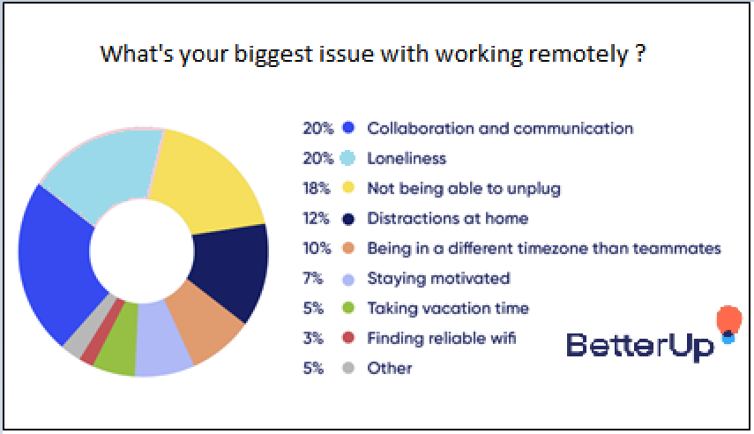

1.Collaboration and communication

Communication between people is one of the most vital aspects of working from home, and it is much more important if you are a stay-at-home worker.  
**How to overcome solve this difficulties**

Consider having an open-door policy so that your staff may come to you for assistance if they have any queries regarding their job or function. To facilitate collaboration with your team, choose the greatest communication technologies available.

2.Loneliness:

According to the National Institute of Occupational Health and Safety (NIOS), a lack of social interaction can make you feel more isolated and lonely, especially if you work from home, and it can affect your mental and physical well-being. The NHS is attempting to reduce workplace loneliness by reducing the number of face-to-face interactions.

**How to overcome solve this difficulties**

Leaders must guarantee that distant workers receive the assistance they require to handle the issues of loneliness.

Best if you video calls with your friend or family within coworking space or library

**3**.Not being able to unplug:

Working and living within the same place might blur the distinctions between work and private life.

This can make it tough to relax and cut at the top of the day, making it challenging to take care of a healthy work-life balance.

**How to overcome solve this difficulties**

Make a home base area for yourself. Even better, if you can, go work someplace else, like a restaurant. This might assist you in establishing boundaries between your professional and private lives.

4. **Distractions at home**:

Even the foremost disciplined and structured remote team members become sidetracked reception.

A stack of dirty dishes or a dusty bookcase may begin to call your name. Then a 20-minute break becomes a two-hour break. those that stand relatives or roommates are likewise subjected to frequent, distracting interruptions.

**How to overcome solve this difficulties**

Find a quiet place in your house to figure and eliminate any distractions. Close the door if possible and ask your roommates to not interrupt you unless an emergency arises.

5. **Being in a different time zone than teammates**

A growing number of companies are operating across various time zones. this will make coordinating with colleagues from other continents difficult.

**How to overcome this challenge**:

To collaborate with foreign teams, use project management software, instant chat, and file-sharing services.

Leaders should encourage teammates to determine and communicate normal working hours to the remainder of the team.

6.Motivation

Working from home, whether as a far off job or as a freelance, can make it easy to lose motivation.

A lack of out of doors feedback and engagement with coworkers might cause you to lose sight of your long-term professional objectives. Eventually, motivation wanes.

When you combine it with the strain of the COVID-19 epidemic, it's no wonder that distant teams are losing motivation.

**How to overcome this challenge**:

Make a listing of your long-term objectives. Include objectives for your job, money, and private desires. Return to them on a frequent basis to stay them fresh in your mind. Consider pinning them on the wall of your office.

Make your manager responsive to your professional objectives so they'll hold you accountable. Attending business events and conferences may additionally provide an exquisite boost in motivation.

7.Taking vacation time:

Vacations are necessary for your physical and emotional well-being. Vacation can boost your productivity, learning ability, and efficiency. Unfortunately, many folks who work from home forget to require breaks.

**How to overcome solve this difficulties**

If you are a leader, prioritize planning your team's holidays to confirm they get adequate relaxation and rest.

8. **Finding reliable WIFI**:

a poor internet connection or out-of-date equipment might frustrate everyone.

**How to overcome solve this difficulties**

Make sure your remote team members have all they have to attach from home, as a pacesetter. confirm you have got access to the foremost recent versions of the programs and software you utilize.

Consider reimbursing internet charges in order that your staff may invest within the quickest connection possible.

As a far off worker, having your personal devices as a backup for your business computer just in case it fails may be beneficial.

Also, select locations around your house that have a wonderful WIFI connection and where you will get in an emergency.

9. Other   
May be Time management:   
-While setting your own schedule may sound like a dream for many remote workers, it is actually a key obstacle of working from home.

While your working hours may be more flexible, you must be disciplined yourself in order to manage your time more effectively to work. You face the danger of procrastinating or taking too many naps if you lack discipline.

## Best APP for working at home

Zoom is that the greatest program for make virtual video meetings and online teaching sessions. Zoom becomes way more useful within the event of complex translation, assisting everyone without interruption.

ZOOM Cloud Meetings may be a meeting and online learning tool with numerous optimum and convenient support functions like swiftly exchanging files and images with meeting members and sending messages with text, graphics, and audio. Most all computer and phone platforms now support the program.



Google Meet could be a video chat service created by Google. From October 2019, this program are accustomed replace Google Hangouts likewise as Google Chat. Google Meet could be a tool built within Google's G-suite that permits users to interact online.

This tool is totally liberal to use for online lessons/meetings with an enormous number of participants, up to roughly 100.



Skype may be a freeware tool that permits you to form voice and video chats with others. Although it's now current owned by Microsoft, it had been initially launched in 2003 by Niklas Luhmann.

Janus Friis and Niklas Zennström (in partnership with Kazaa developers Ahti Heinla, Priit Kasesalu, and Jaan Tallinn). you'll use Skype to exchange instant conversations and share files with friends, family, coworkers, and anyone else you would like to talk with from anywhere within the globe. you'll be able to use Skype to measure chat with one or more individuals as long as you have got an online connection.



## Conclusion and propose an initial hypothesis

The preceding research provided several results that have a significant impact on the project; secondary investigations have revealed the problems of working from home, such as:

• Easily distracted

• Inability to manage staff

• Inadequate physical circumstances

• Infrequent communication

Or apps, things that a firm may do to best accommodate workers who work from home, such as:

• Microsoft Teams

• Zoom

Secondary research has supplied the required conditions for an app, such as a design that avoids distractions, a management system for attendance, or an online call system to connect members. Investigate popular applications to integrate some of the concepts you already have into one full-featured product.

### Hypotheses for research:

We need an app that can do:

• has a simple design

• can upload and download projects

• interact (phone, chat, remark)

• manage staff

Using a clock work, such as Pomodoro, to improve performance and regulate the time each person works

The app was reviewed using primary research through surveys and direct talks amongst project leaders based on the theoretical basis and research model of variables impacting working from home, and the findings are shown below. achieved outcome:

• Good attendance system

• Design features that are not too eye-catching

• Clock to track employee performance properly -> Reward workers who have adequate time to work and accomplish their task well

# PRIMARY RESEARCH

## Research Subject

In this study, The introduction and comprehension of the research objectives will assist the project in not becoming confused, allowing orientations to direct the implementation of the objectives. The following stages will be directed when there are defined objectives: Research object, research scope, and topic-appropriate research methodologies

The research paradigm may be used to a wide range of disciplines, including computer, social, human, and economic research. However, the scope of the procedure also explicitly outlines the methodologies for studying the computational research that the research is conducting.

### -Research Object

In this article, I will note two things:

o Firstly, it's the issue of Stay motivated that affects working remotely

o Second, I would like to discuss ways to stay motivated

### -Research Plan

#### Phase 1: Negative Impact of Working remotely

The fact is Working Remotely have a lot of advantage and disavantages like effects on adults, that effect their behaviour and it will make unhealthy their life

1.Collaboration and communication

Not good communication will hurt their life experiencing and their job



2.Loneliness:

According to the National Institute of Occupational Health and Safety (NIOS), a lack of social interaction can make you feel more isolated and lonely, especially if you work from home, and it can affect your mental and physical well-being.

The NHS is attempting to reduce workplace loneliness by increase the number of face-to-face interactions.



**3**.Not being able to unplug:

If you are not yourself, life becomes meaningless and blurred



4. **Distractions at home**:

Frequent, distracting interruptions from other stuff on their house make reduce their productivity



#### Phase 2: Population research Population

In this section, I will provide data about my participants. My research is aimed at people 18 years of age and older. Population figures are not detailed at the moment, so I don't know the total number of adults over the age of 18. Because my human resources are limited, I don't have enough desire to research everyone in Vietnam. So, I will randomly survey people from 18 years old in 3 cities Saigon, Hanoi and Da Nang to collect data. My research scaled around 100 people in 3 cities. Because the population is not known explicitly and the probability of an individual is unknown, it will yield the most objective result.

### Sample Size

My sample size is expected to be 100 people with adult aged over 18 years old and currently working in one of the three cities of Saigon, Hanoi and Danang.

### Sampling Methods

Non-probability sampling was the strategy I employed for this study's sampling. In this sample, because the items were picked randomly and there is no method to assess the odds of those provided elements. Furthermore, no uncertainty is added, therefore everybody has a possibility of getting included, making estimating the sample variability impossible. This approach has the benefit of being simple to implement. In research, there are two methods for sampling non-probability subjects: quota sampling and convenience sampling.

## Research Plan

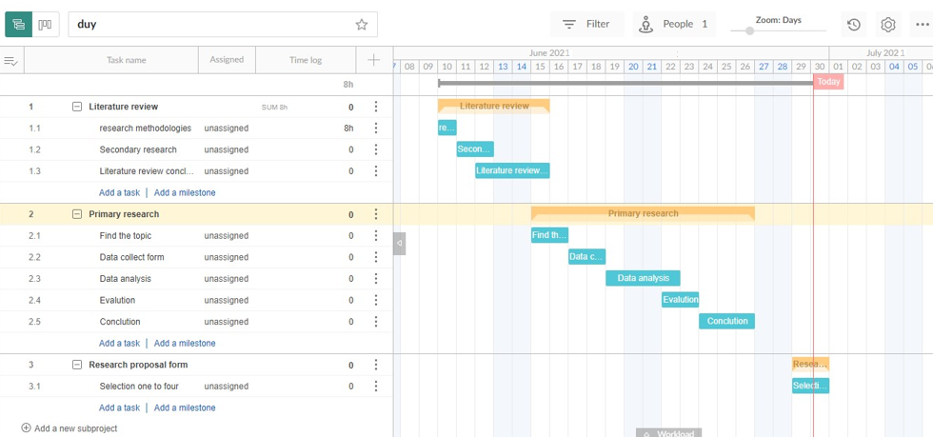

### Phase 3: Survey adult who have over 18 years old

Link… [Analysis Result of Demographic Profile of Respondents - Google Forms](https://docs.google.com/forms/d/18phfAV5uolGxyuwJOsKFc70_6cDOEuW5PWXnefx3WNc/edit#responses)

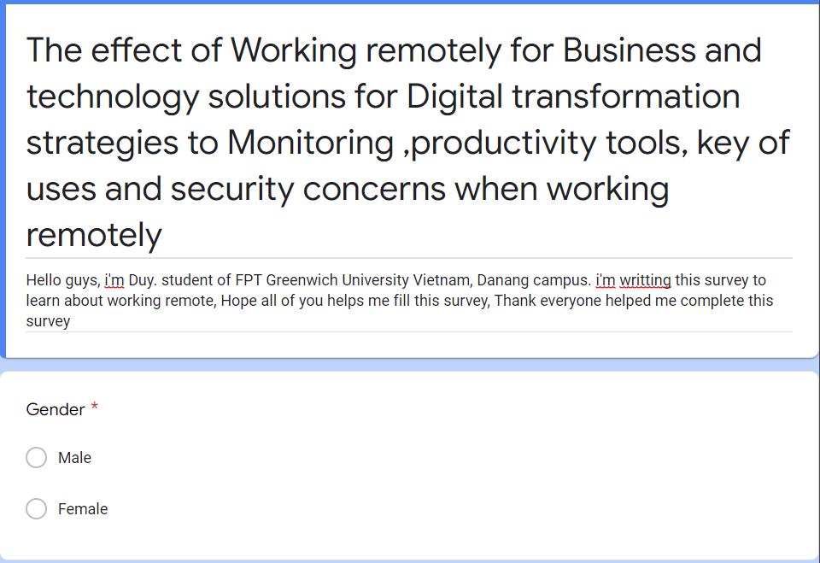



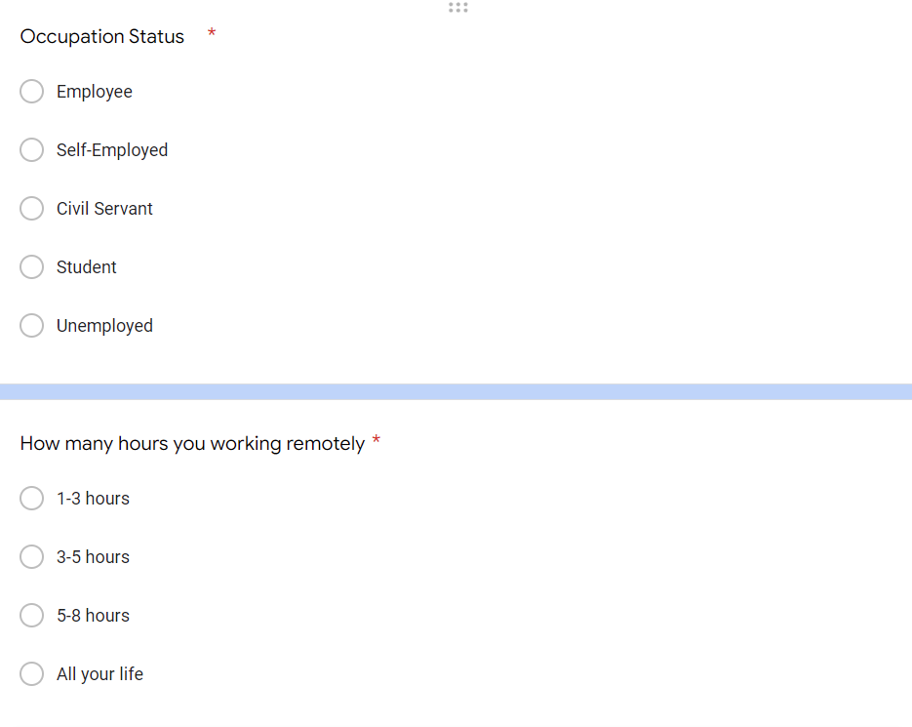



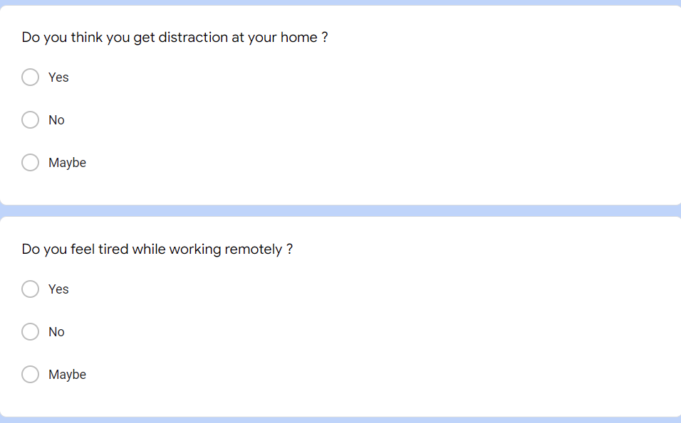

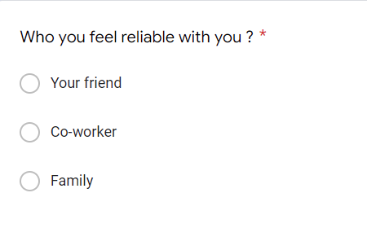

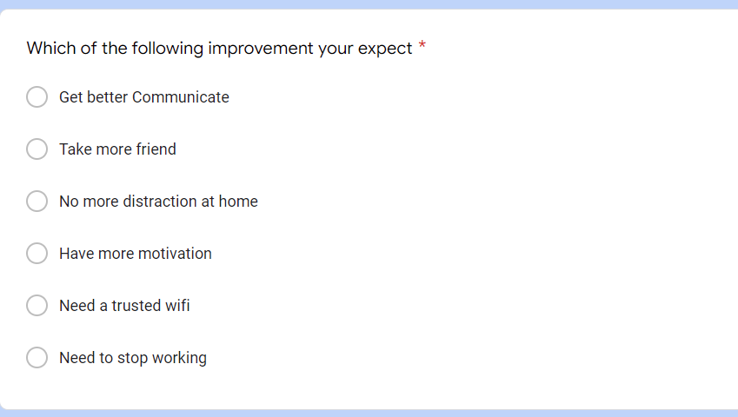

### Phase 4: Analyze the collected data after the survey

After surveying 100 people, I will show the results of the survey to analyze them…

This is example of 6 people…

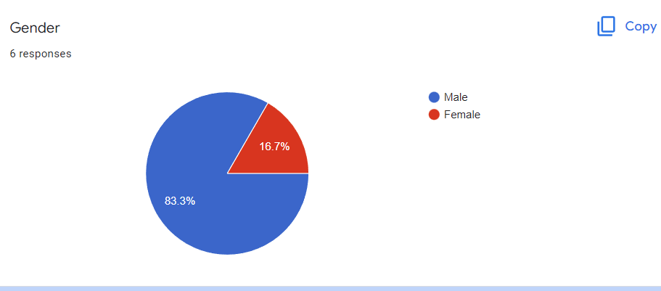

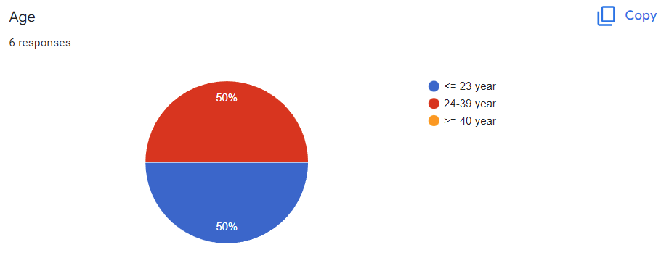

Sound like ,it’s almost around 18-39 years old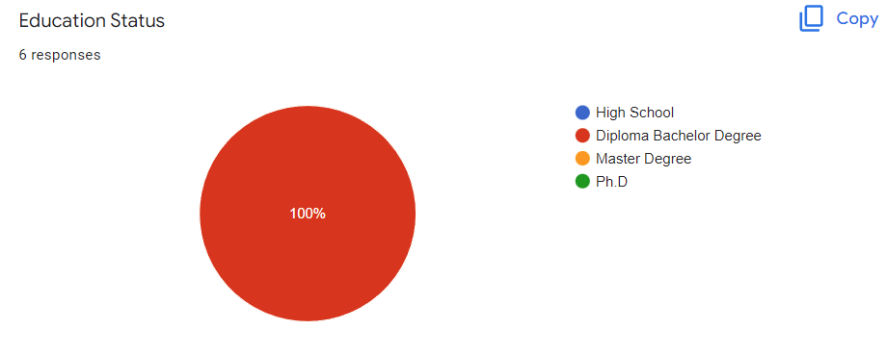 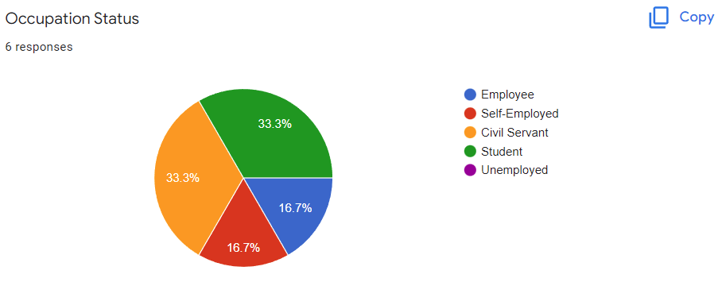 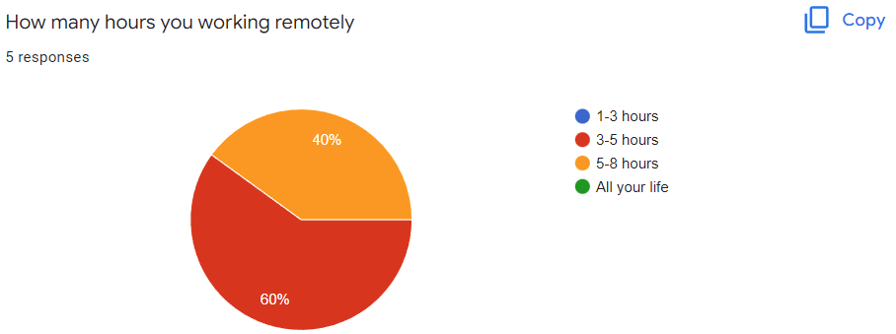 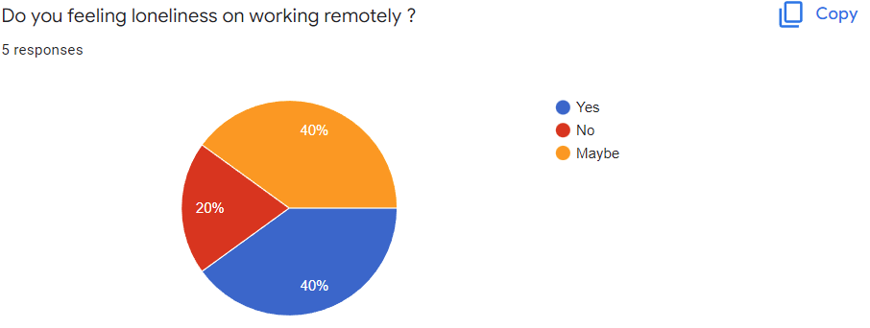 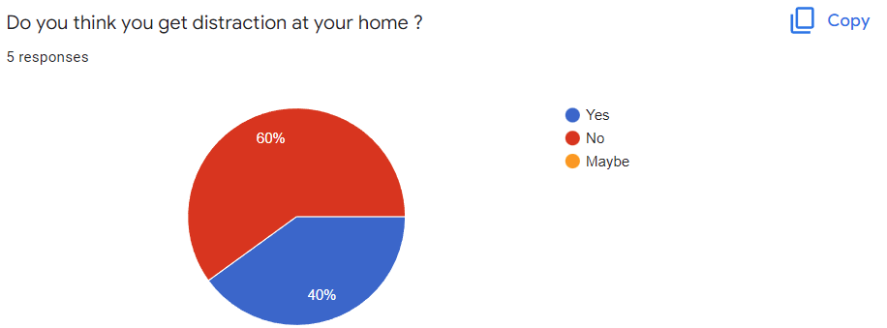 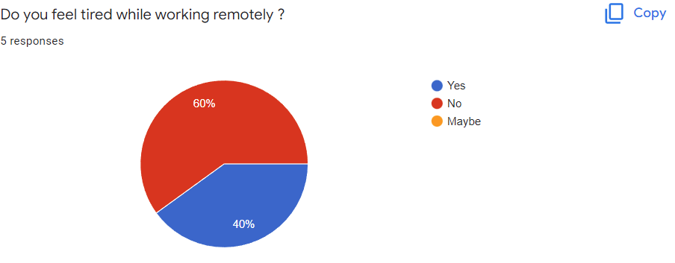 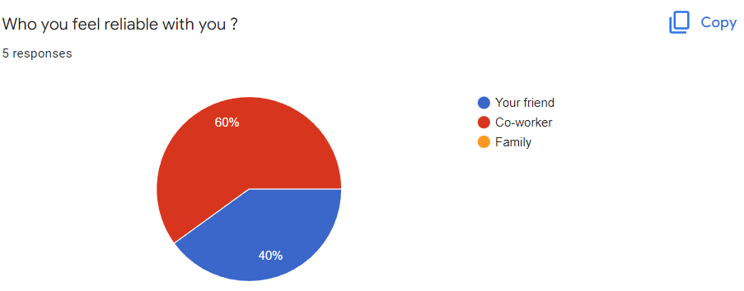 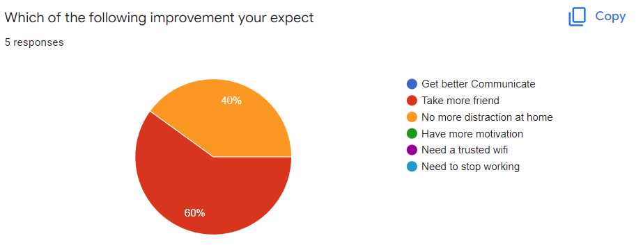

As a result, 60% Seeem we need more friends than others

## -Research Ethics Approval Form



**Section One: Basic details**

Project title: ....................... Working remotely for Business and technology solutions.............................................................................................................................................................................................................................................

.........................................................................................................................................................................................................................................................................................................

Student name: ..................................................... Nguyễn Trọng Duy......................................................................................................................................................................................................

Student number: ........................................... GCD17313....................................................................................

Programme: ..................................................................................................................................................................................................................................................................

School: ....................................................FPT Greenwich University............................................................................................................................................................................................................................

Intended research start date: .........................................................................................

Intended research end date: ...........................................................................................

**Section Two: Project summary**

Please select all research methods that you plan to use as part of your project:

• Interviews **X**

• Questionnaires

• Observations **X**

• Use of personal records **X**

• Data analysis **X**

• Action research

• Focus groups

• Other (please specify): ...................................................................................................................................................................................................................................

**Section Three: Participants**

Please answer the following questions, giving full details where necessary.

Will your research involve human participants? Yes

Who are the participants? Tick all that apply:

Children aged 12–16: □  Young people aged 17–18: □  Adults: **X** □

How will participants be recruited (identified and approached)? They’re adult

Describe the processes you will use to inform participants about what you are doing:

-Ask people are adults. Give them form to answer question

How will you obtain consent from participants? Will this be written? How will it be made clear to participants that they may withdraw consent to participate at any time?

-Tell them this questionaire will help their job in future and give them rules

**Studies involving questionnaires:**

Will participants be given the option of omitting questions they do not wishto answer?

Yes: □ **X** No: □

If No please explain why below and ensure that you cover any ethical issues arising from this:

**Studies involving observation:**

Confirm whether participants will be asked for their informed consent to be observed.

Yes: □  **X** No: □

Will you debrief participants at the end of their participation (i.e. give them a brief explanation of the study)?

Yes: □  **X** No: □

Will participants be given information about the findings of your study? (This could be a brief summary of your findings in general.)

Yes: □  **X** No: □



**Section Four: Data storage and security**

Confirm that all personal data will be stored and processed in compliance with the Data Protection Act (1998):

Yes: □ **X**   No: □

Who will have access to the data and personal information?

**During the research:**

Where will the data be stored?

Will mobile devices (such as USB storage and laptops) be used?

Yes: □ **X**   No: □

If yes, please provide further details:

**After the research:**

Where will the data be stored? -Use laptop and send them to CLOUD more safer

How long will the data and records be kept for and in what format?

Will data be kept for use by other researchers?

Yes: □ **X**   No: □

*If yes, please provide further details:*

**Section Five: Ethical issues**

Are there any particular features of your proposed work which may raise ethical concerns? If so, please outline how you will deal with these:

It is important that you demonstrate your awareness of potential risks that may arise as a result of your research. Please consider/address all issues that may apply. Ethical concerns may include, but are not limited to the following:

* Informed consent. **X**
* Potentially vulnerable participants **X**.
* Sensitive topics. **X**
* Risks to participants and/or researchers. **X**
* Confidentiality/anonymity. **X**
* Disclosures/limits to confidentiality. **X**
* Data storage and security, both during and after the research (including transfer, sharing, encryption, protection). **X**
* Reporting. **X**
* Dissemination and use of your findings. **X**

**Section Six: Declaration**

I have read, understood and will abide by *[insert centre name]* Research Ethics Policy:

Yes: **X** □  No: □

I have discussed the ethical issues relating to my research with my Unit Tutor:

Yes: **X** □  No: □

**I confirm that to the best of my knowledge:**

The above information is correct and that this is a full description of the ethics issues that may arise in the course of my research.

Name: ........................... Nguyễn Trọng Duy...............................................................................................................................................................................................................................................

Date: ...................................................................................

**Please submit your completed form to:** ...................... Phyo Min Tun................................................................................................................................................



# CONCLUSION

In this report, I have absorbed a lot of knowledge such as primary and secondary research, scientific method and research process, primary and secondary research. Next came the secondary research, which helped me understand the different types of interests and better understand digital interests. In the primary part, I mentioned the research object, the research plan for a specific problem. In the end, I surveyed 100 people and helped me better understand the impact of Teleworking for Business and technology solutions for Digital to Surveillance strategies, productivity tools, usage lock and remote working security concerns

# Bibliography

Das, Arindam. “Market Research Techniques for Primary and Secondary Research.” *IMS Proschool Offers Courses in Data Science, Digital Marketing, IFRS, ACCA, CFA, Business Analytics, Financial Modeling, CIMA, CFP Courses* (blog), March 26, 2019. <https://www.proschoolonline.com/blog/market-research-techniques-for-primary-and-secondary-research>.

Szerovay, Krisztina. “Secondary Research.” Medium, May 7, 2019. <https://uxknowledgebase.com/secondary-research-b19ecb6f646f>.

Roller, Margaret R. “Qualitative Data: Achieving Accuracy in the Absence of ‘Truth.’” *Research Design Review* (blog), November 21, 2016. <https://researchdesignreview.com/2016/11/21/qualitative-data-achieving-accuracy-in-the-absence-of-truth/>.

WallStreetMojo. “Quantitative Research,” October 18, 2019. <https://www.wallstreetmojo.com/quantitative-research/>.

dcnewton. “Working Remotely: The Future of Sustainability?” Office of Sustainability - Student Blog, April 3, 2020. <https://usfblogs.usfca.edu/sustainability/2020/04/03/working-remotely-the-future-of-sustainability/>.

“Tools for Remote Working - Mentimeter.” Accessed June 3, 2022. <https://www.mentimeter.com/campaigns/tools-for-remote-working>.

expii. “Scientific Method — Steps & Importance.” Accessed June 3, 2022. <https://www.expii.com/t/scientific-method-steps-importance-11026>.

Australian Environmental Education. “The Scientific Method Is a Process for Experimentation.” Accessed June 3, 2022. <https://www.australianenvironmentaleducation.com.au/education-resources/what-is-the-scientific-method/>.  
Business News Daily. “Zoom Video Conferencing 2022 Review - Businessnewsdaily.Com.” Accessed June 10, 2022. <https://www.businessnewsdaily.com/11282-zoom-video-conferencing.html>.

“Skype | Stay Connected with Free Video Calls Worldwide.” Accessed June 10, 2022. [https://www.skype.com/en//](https://www.skype.com/en/).

“Google Meet, Hangouts, and Chat: Everything You Need to Know.” Accessed June 10, 2022. <https://zapier.com/blog/google-hangouts-meet-guide/>.